AP Research

Summer 2022 Assignment

Due Tuesday, August 9th, 2022

**Overview of Assignment:**

**Part I:** Chapter 1 in Practical Research Planning and Design

**Part II:** Chapter 3 in Practical Research Planning and Design

**Part III:** Background Research & Annotated Bibliography

**Part IV:** Research Question Graphic Organizer

**Part V:** Expert Advisor Log

The activities in this packet are designed to help you prepare for AP Research- it is a substantial amount of work, but there is a method to the madness.

* Parts I & II are background readings that are designed to help you better understand what research is and how to develop an effective research question.
  + Recommended completion: June
* Part III is the most crucial aspect to complete this summer because you cannot develop an effective research question without doing a wide range of reading around your topic. Part III, therefore, should take the most amount of time and should be something that you work on throughout the summer, schedule permitting.
  + Recommended completion: June & July
  + *Will be shared with your peers when you return to school*
* Part IV is a graphic organizer to get you to start developing your topic once you have read widely about it.
  + Recommended completion: July
  + *Will be shared with your peers when you return to school*
* Part V is probably the least amount of “work,” but should only be undertaken last: you don’t want to be reaching out to potential expert advisors if you don’t have an idea of the direction you are going to head in and have done a fair bit of background reading.
  + Recommended completion: end of July, beginning of August

**Support & Collaboration:**

I am offering the following optional sessions over the summer. I am of course available via email or even a Teams call to answer any questions. I also recommend working with your peers outside of these scheduled discussions.

* **Wednesday, June 15:** **Discussion of Chapters 1 & 3 of Research Planning & Design**
  + **1pm-3pm**: Otherlands Coffee, 641 S. Cooper Street, Memphis, TN 38104
* **Wednesday, July 6: Discussion & Work Time on Background Readings & Annotated Bibliography**
  + **1pm-3pm:** French Truck Coffee, Crosstown Concourse, 1350 Concourse Ave #167, Memphis, TN 38104
* **Wednesday, July 20th: Discussion & Work Time on Research Question Graphic Organizer & Expert Advisor Log**
  + **1-3pm:** Belltower Coffeehouse, 525 S. Highland St, Memphis, TN 38111

Part I: Chapter 1 in Practical Research & Design

After reading Chapter 1 of Practical Research & Design, type your answers to each question below.

“What Research is Not” pg. 1-2

* What surprised you in this section? Why?
* According to this section, how is AP Seminar different from AP Research? Explain your answer using textual evidence to emphasize your claims.

“What Research Is” pg. 2-7

* What part of this section interests you? Why?
* According to this section, how is AP Research an extension of AP Seminar?

“The Research Cycle,” Figure 1.1 pg. 7

* How does this diagram represent that the research process is cyclical?

“Reflective Questions to Consider When Evaluating Research” pg. 10

* Which of these questions seem the MOST important to ask yourself when evaluating research?
* Be sure to apply these reflections when moving onto Part III of this assignment. (This is not a question, just a tip from Ms. Young!)

“Guidelines: Benefiting from Others Research” pg. 11

* Guideline 1 encourages you to keep a running record of articles that could be helpful for your research. This is a great time to start thinking about a system you will use to organize your research this summer and into next year. Will you use Google drive and folders? OneDrive and your school account? Briefly explain the system you plan to use this summer and next year to keep yourself organized.

Part II: Chapter 3 in Practical Research & Design

After reading Chapter 3 of Practical Research & Design, type your answers to each question below.

“Finding Research Projects” pg. 44-46

* What is the difference between basic & applied research?
* What are the two criteria for a research question?

“Guidelines: Finding a Legitimate Problem” pg. 46-48

* Of the guidelines posed in this section, I find tips 1, 2, and 5 to be the most important for our class. Summarize the advice encouraged in those three tips.

“Guidelines: Stating the Research Problem,” pg. 48-52

* We have discussed some of these topics in class before, but tip 2 regarding feasibility is especially meaningful for AP Research. Summarize the tips offered for choosing feasible research projects.
* The checklist on page 52 will be helpful to reflect upon when completing the graphic organizer for Part IV, so be sure to revisit these questions when completing Part IV. (This is not a question, just a tip from Ms. Young!)

Part III: Background Research & Annotated Bibliography

Part III of this assignment is the most crucial- summer is an indispensable time for you to explore ideas without the constraints of your other classes, activities, and more that crowd the school year. USE THIS TIME TO YOUR ADVANTAGE.

I recognize that we all are likely in different areas in regards to having a topic in mind. Therefore, read through the list below and begin at whatever stage best summarizes where you are in regards to your topic.

STEP 1: I Have No Idea What My Field or Topic Will Be: Take the first few weeks of the summer and every day, pick a few stories to read from a credible news source, like the New York Times or local papers like the Commercial Appeal or Daily Memphian. Don’t only read the news section: read Arts and Entertainment, Sports, etc. – whatever interests you. Rotate your news source (NPR is an excellent source for less main-stream topic ideas). Create a jot list of articles (including date and author) that peak your interest and add to that list each week. At some point, try to start narrowing your field and only read articles in that field. By the beginning of July, look through your list of articles and narrow to 2-3 topics that really appeal to you. Move on to category 2. *Note: this process is not “due” as part of this assignment- these are just guidelines.

STEP 2: I Know My Field: If you know the academic field or area of research you want to pursue, spend some time looking at topics within that field. Read and listen to various news sources, do some digging, and identify two potential topics within your field of choice. For each topic option, do some reading and reflecting. Maybe even make a trip to a library- don’t be afraid to approach librarians for help! As you read, make note of 1) what seems to be out there in the way of usable material, 2) benefits to researching each topic, and 3) drawbacks to researching each topic. Move on to category 3. *Note: this process is not “due” as part of this assignment- these are just guidelines.

STEP 3: I Know My Basic Topic: Begin searching to see what has already been written on your general topic. Your goal is to search for an untapped/ unexplored angle – where is there a gap or a hole in the conversation on this subject; what needs to be added? How can you make it original AND feasible?

Carefully read & annotate five academic articles about your topic. Then, create a 5-source annotated bibliography (instructions on the next two pages) with citations in MLA format. All 5 sources should be credible enough to use down the road, and you will be sharing these sources with your peers when we return to school. *Note: THIS IS THE PART OF THE ASSIGNMENT THAT IS DUE. It is expected that you get to Category 3 by the end of the summer. Please create your annotated bibliography as a separate word document and email it to [youngm4@scsk12.org](mailto:youngm4@scsk12.org)

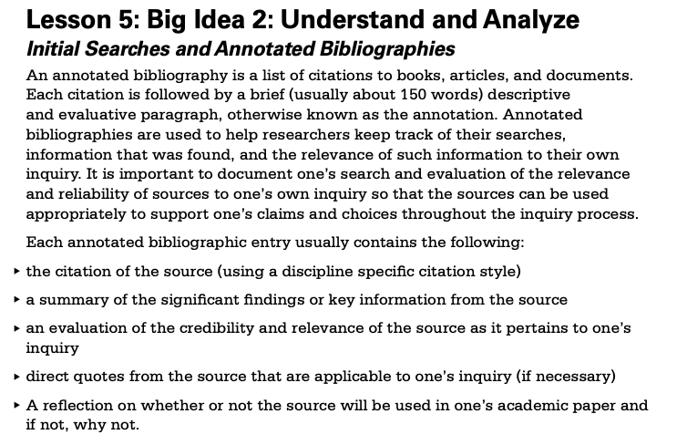

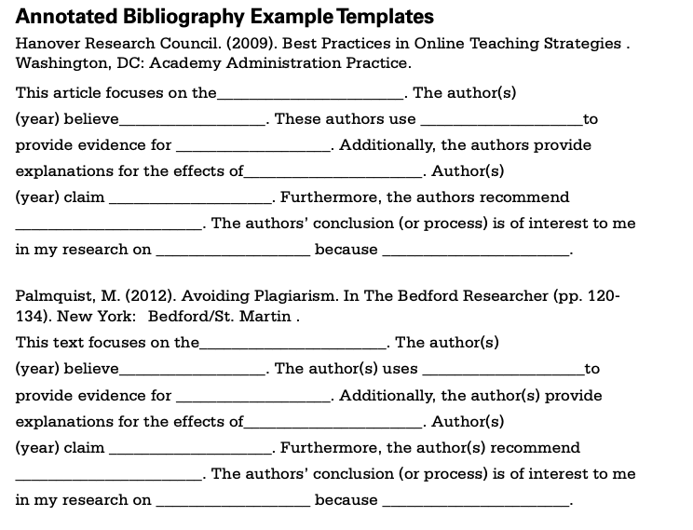

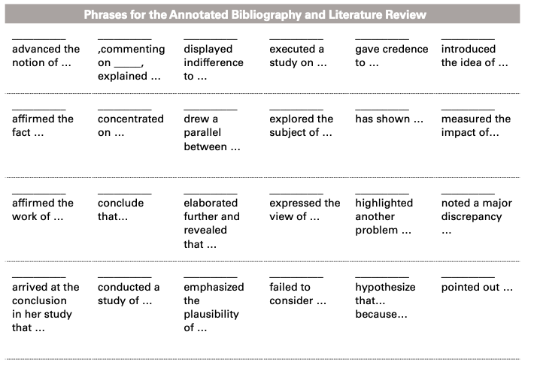

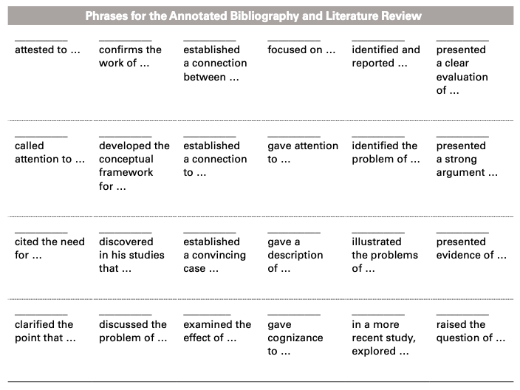

Part IV: Research Question Graphic Organizer

You may complete this graphic organizer either by creating text boxes to type into on this document OR by recreating this graphic organizer in your own document and emailing it to youngm4@scsk12.org.

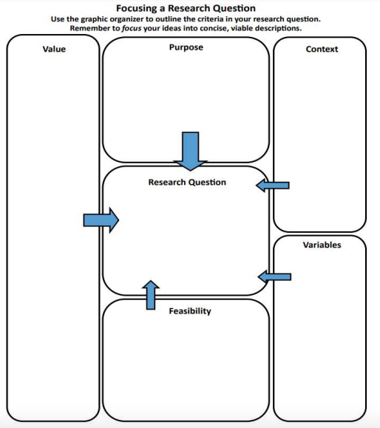

Part V: Expert Advisor Log

After you have completed parts III and IV in particular, research experts that have knowledge about your topic: people that wrote the information you found interesting or people who have done research in these areas. You will need to make phone calls and emails to begin to make those relationships which can serve to better your research project. Keep track of these contacts. You should make at least three different contacts with potential expert advisors before the year begins. Complete these tables by typing into them.

Contact #1:

| Contact Name: |  |
| --- | --- |
| Phone and/or Email: |  |
| Field of Expertise: |  |
| Summary of Contact, Including Date: |  |

Contact #2:

| Contact Name: |  |
| --- | --- |
| Phone and/or Email: |  |
| Field of Expertise: |  |
| Summary of Contact, Including Date: |  |

Contact #3:

| Contact Name: |  |
| --- | --- |
| Phone and/or Email: |  |
| Field of Expertise: |  |
| Summary of Contact, Including Date: |  |